Course Code: CSA1557

Course Name: Cloud Computing and Big Data Analytics

M.Gowripriya

192224223

4) Create a simple cloud software application for Library book reservation system for SIMATS library using any Cloud Service Provider to demonstrate SaaS include the necessary fields such as Title of the book, author, publications, 6 Year, edition, no of copies, Rack no, status (taken/returned) etc

AIM: To Create a simple cloud software application for Library book reservation system for SIMATS library using any Cloud Service Provider to demonstrate SaaS

PROCEDURE:

step1: Go to zoho.com.

step 2: Log into the zoho.com.

step 3: Select one application step.

step4: Enter application name as library book reservation system.

step 5: Created new application as library book reservation system.

step 6: Select one form

step 7: The software has been created.

IMPLEMENTATION:

STEP1: GOTO ZOHO.COM

STEP 2: LOGIN TO THE ZOHO.COM

STEP 3: SELECT ONE APPLICATION

STEP 4: ENTER APPLICATION NAME

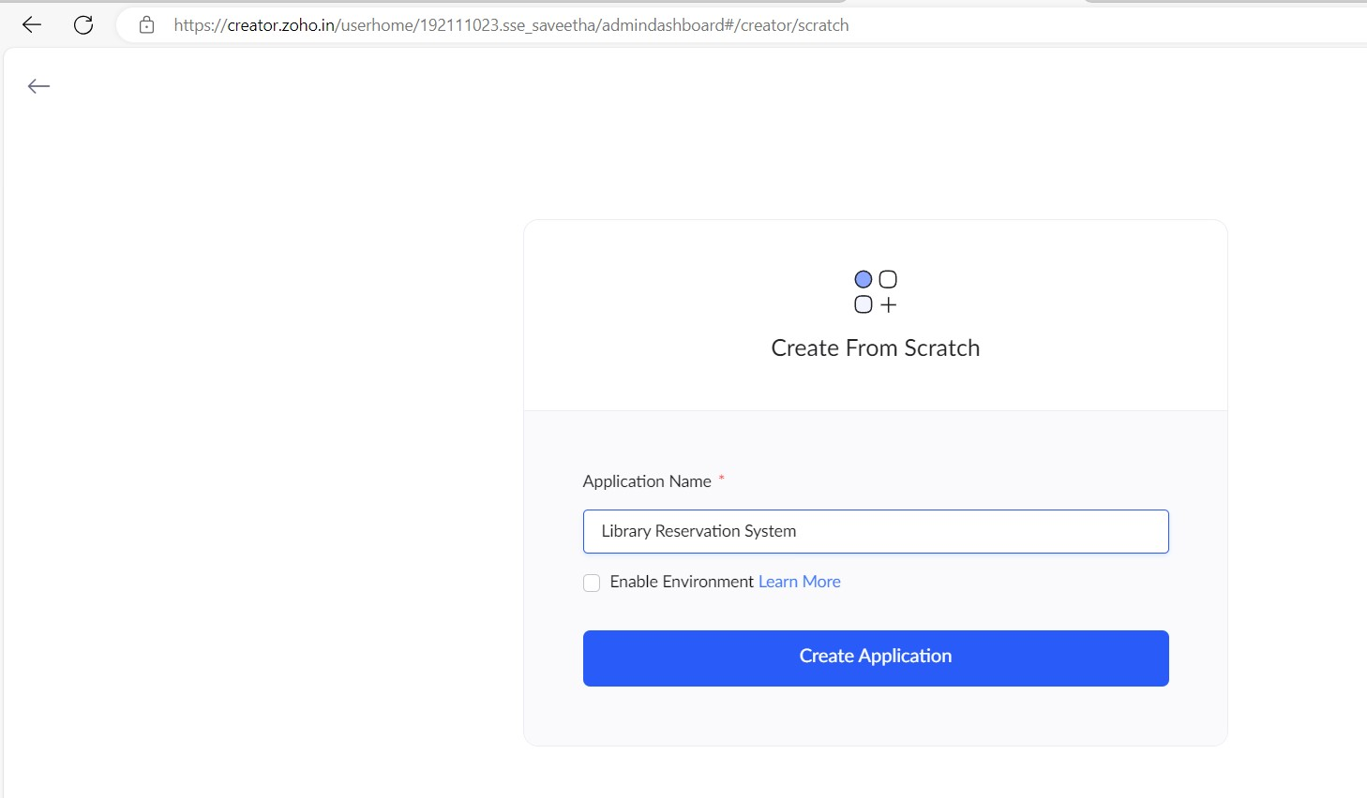

STEP 5: CREATED NEW APPLICATION

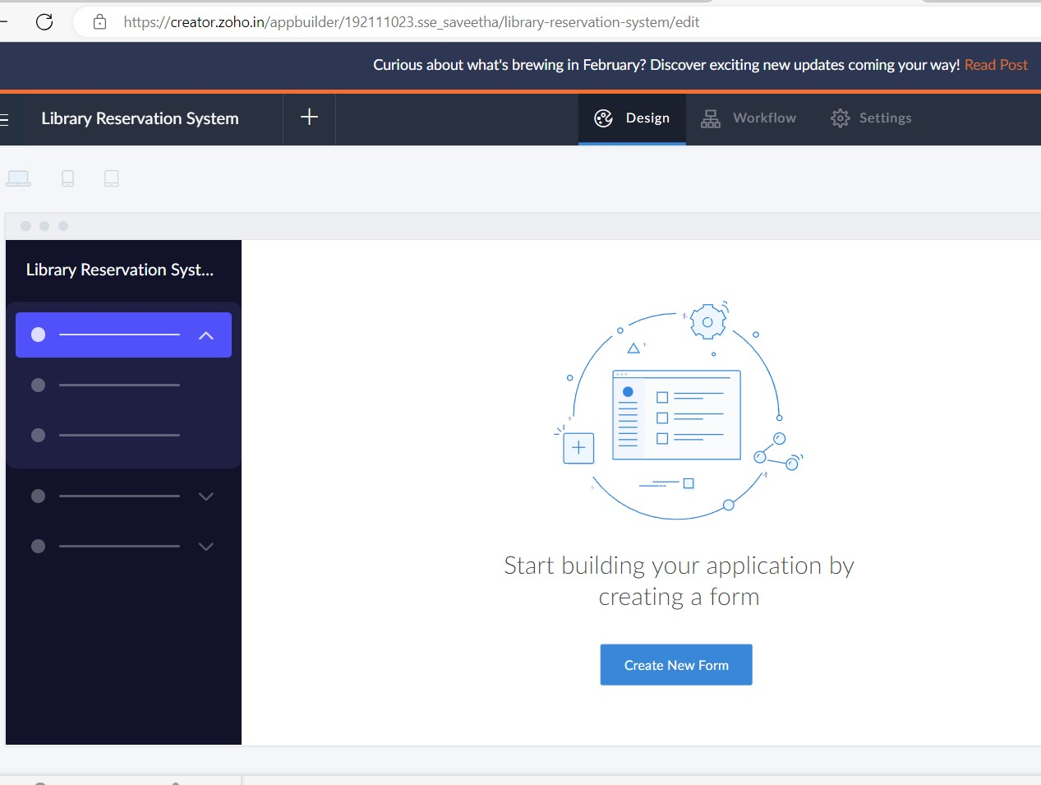

STEP 6: Select from Stratch and Create form as login.

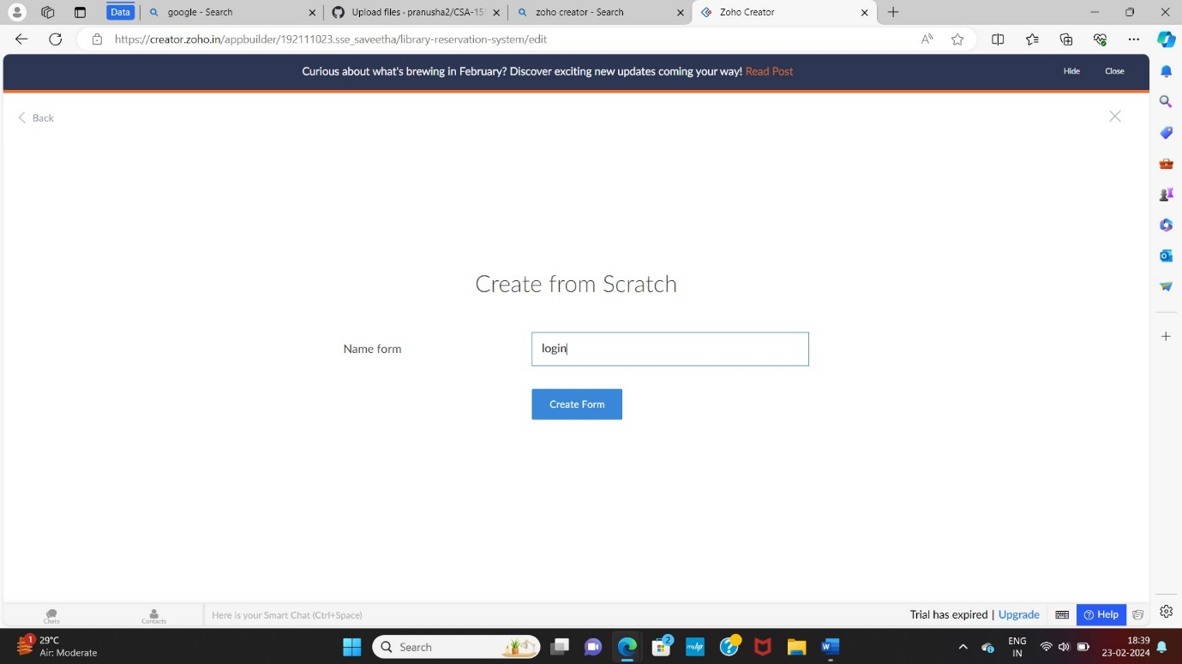

STEP 7: The form has been created as login.

Choose the fields.

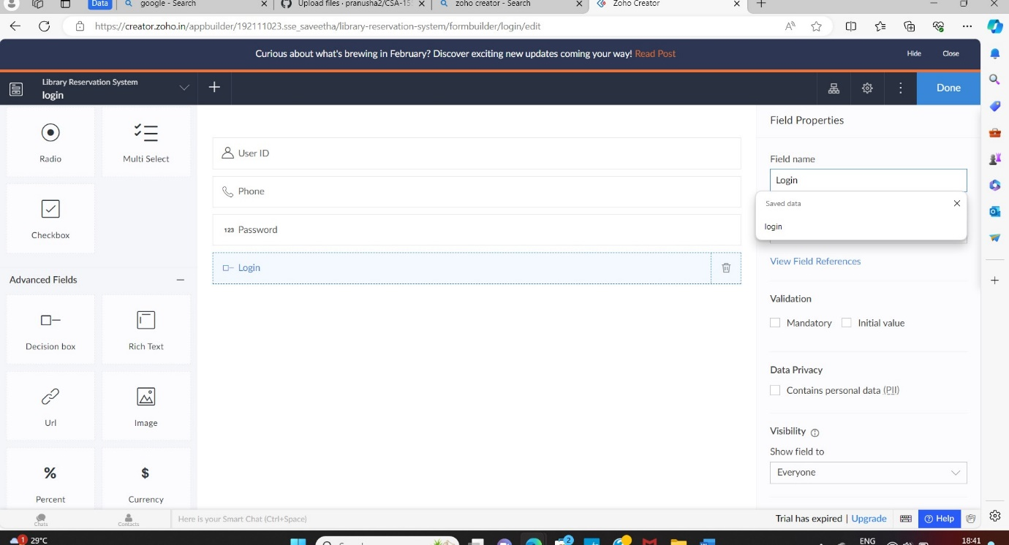

STEP 8: Click Access Development Live and enter the details to access.

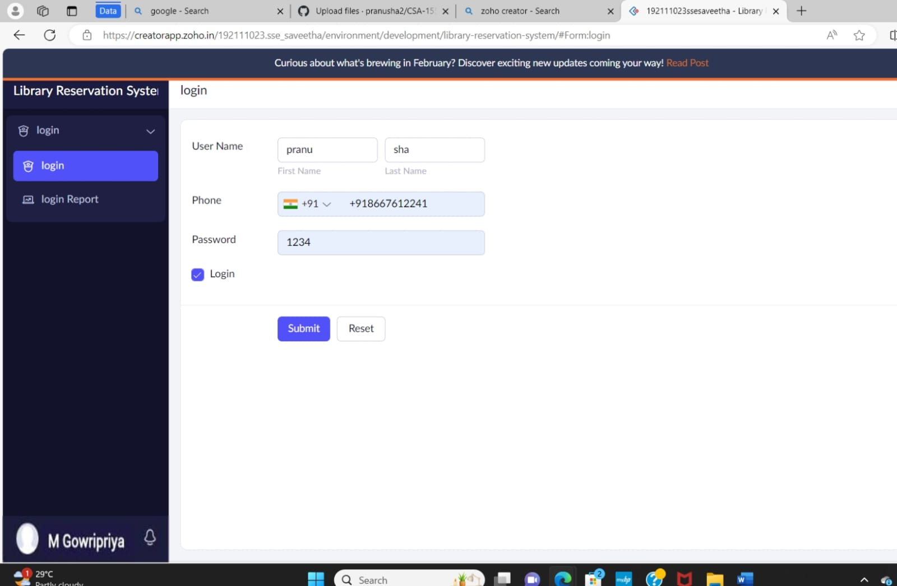

STEP 9: The report has been registered in the login report.

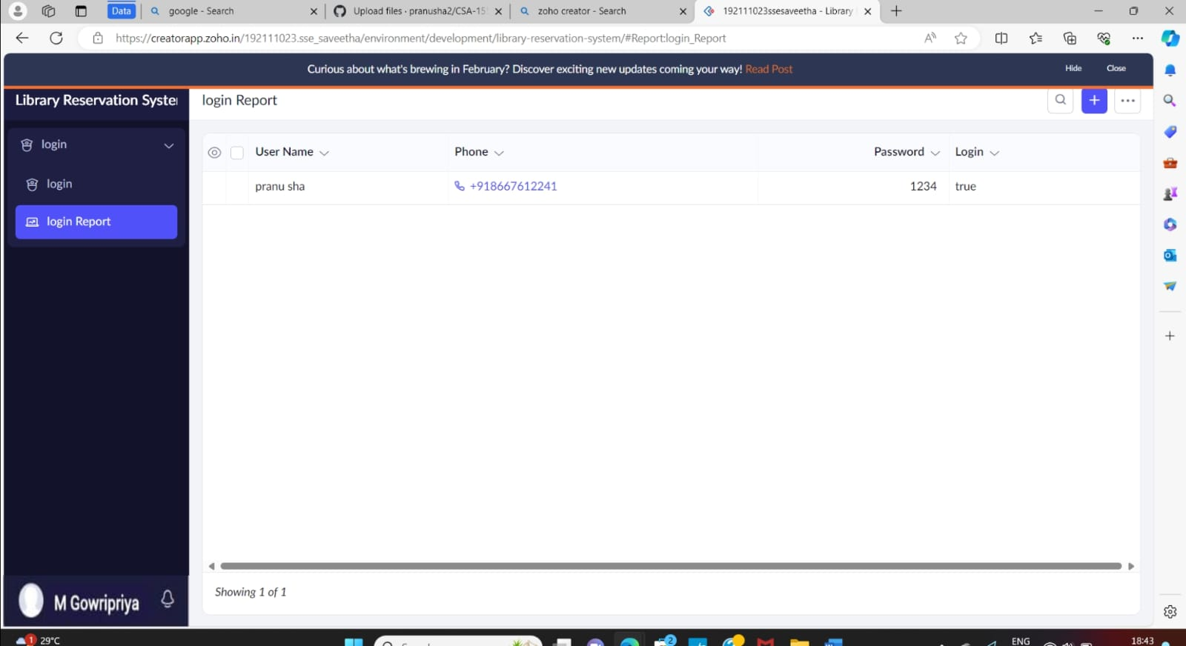

STEP 10: Create a form as Library membership form

STEP 11: The form has been created as Book

Choose the fields.

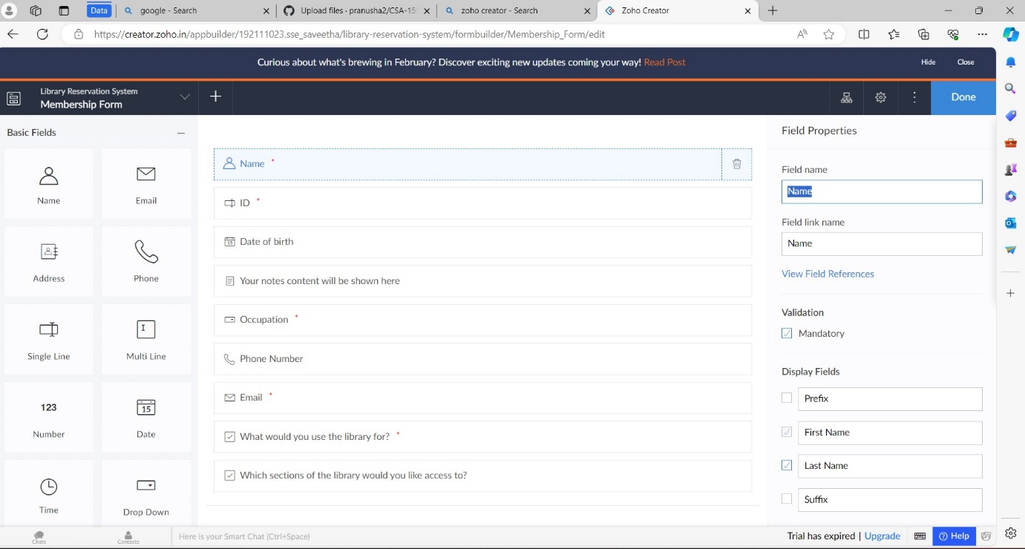

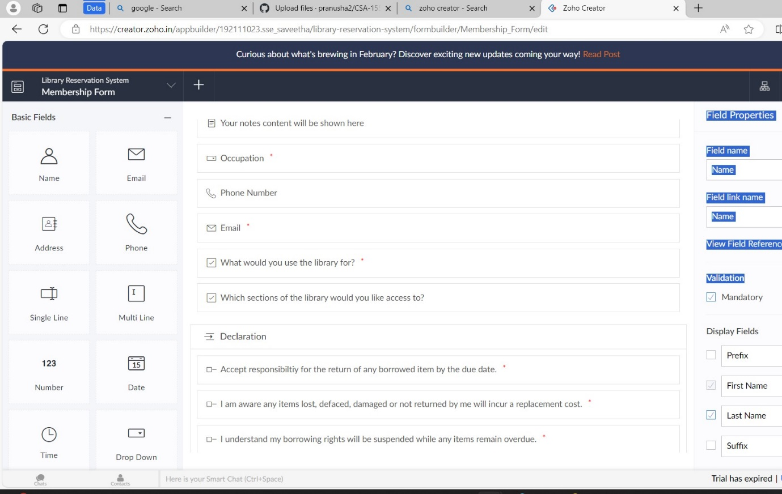

STEP 12: Click Access Development Live

STEP 13: Enter the details of the Member.

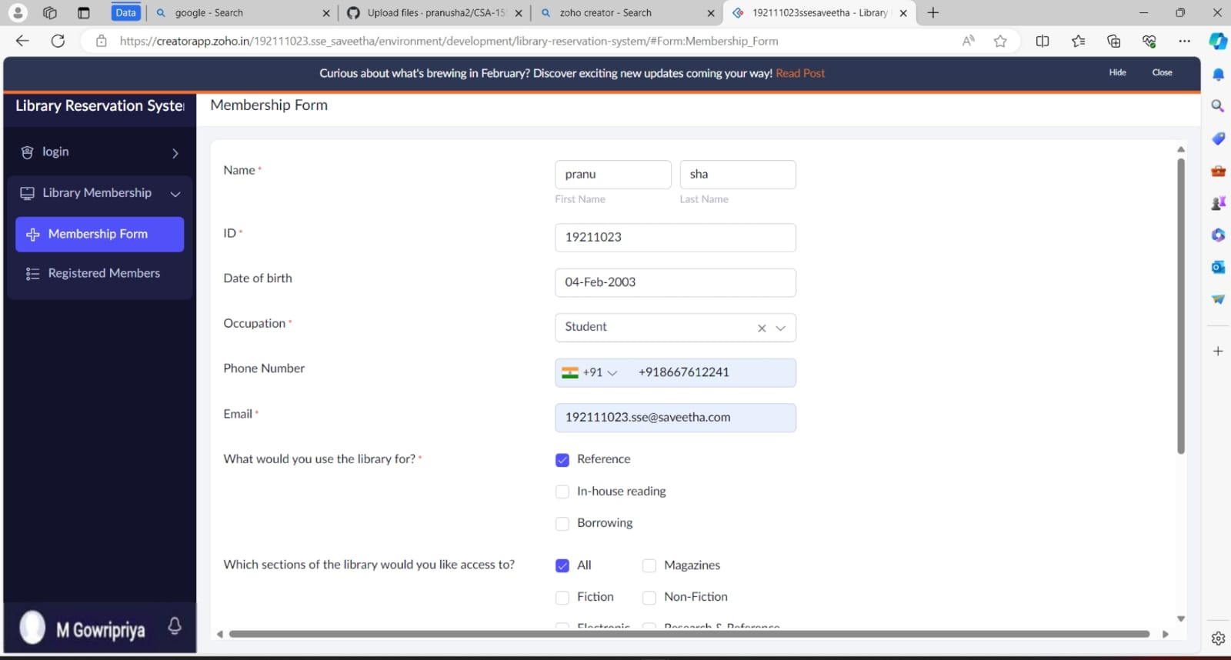

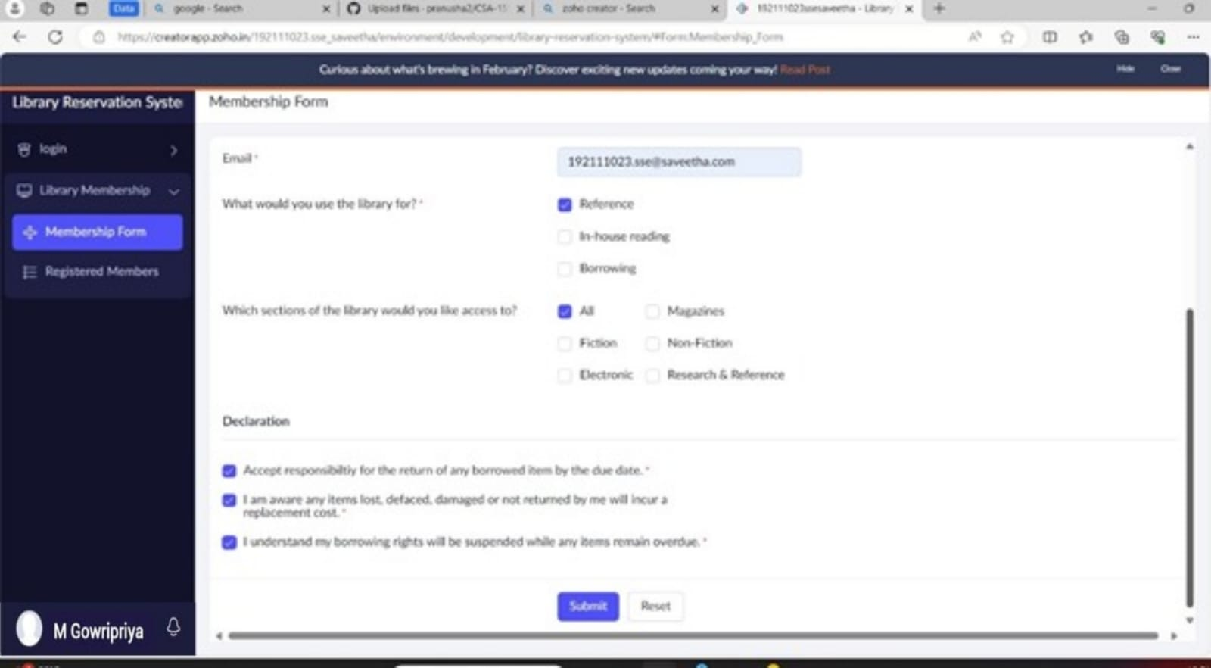

STEP 14: The report has been registered in the Membership form report.

STEP 15: Select from Stratch and Create form as Book.

STEP 16: The form has been created as Book

Choose the fields.

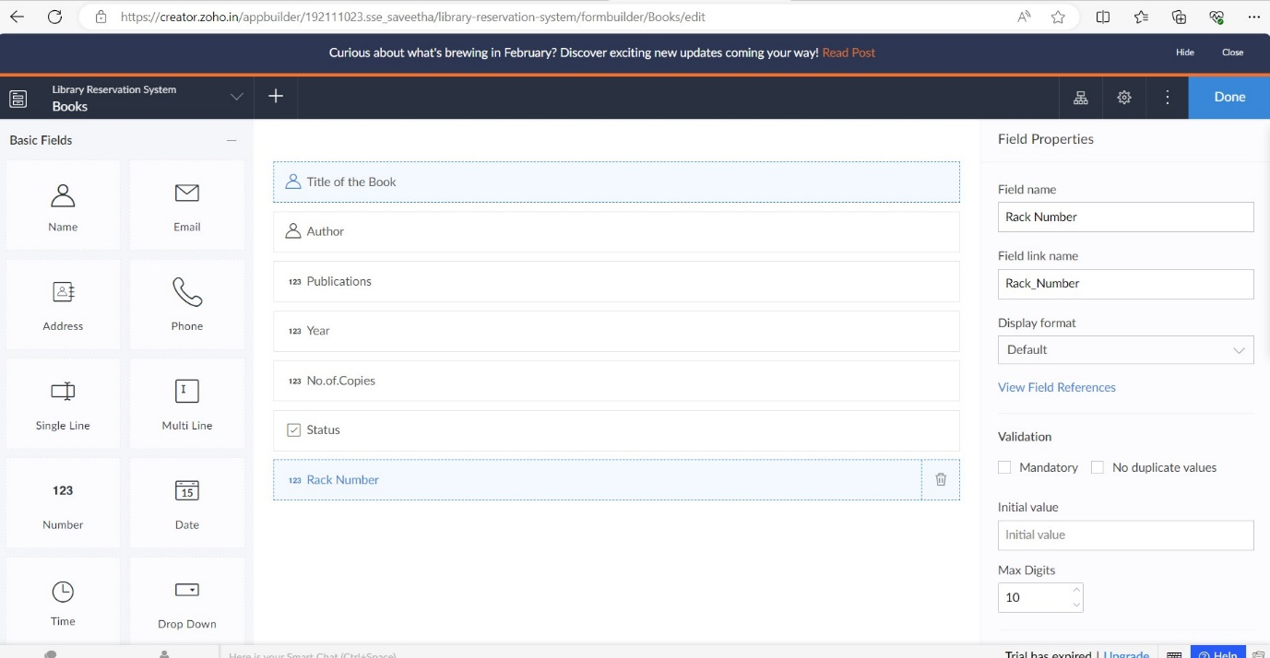

STEP 17: Click Access Development Live

STEP 18: Enter the details of the Book.

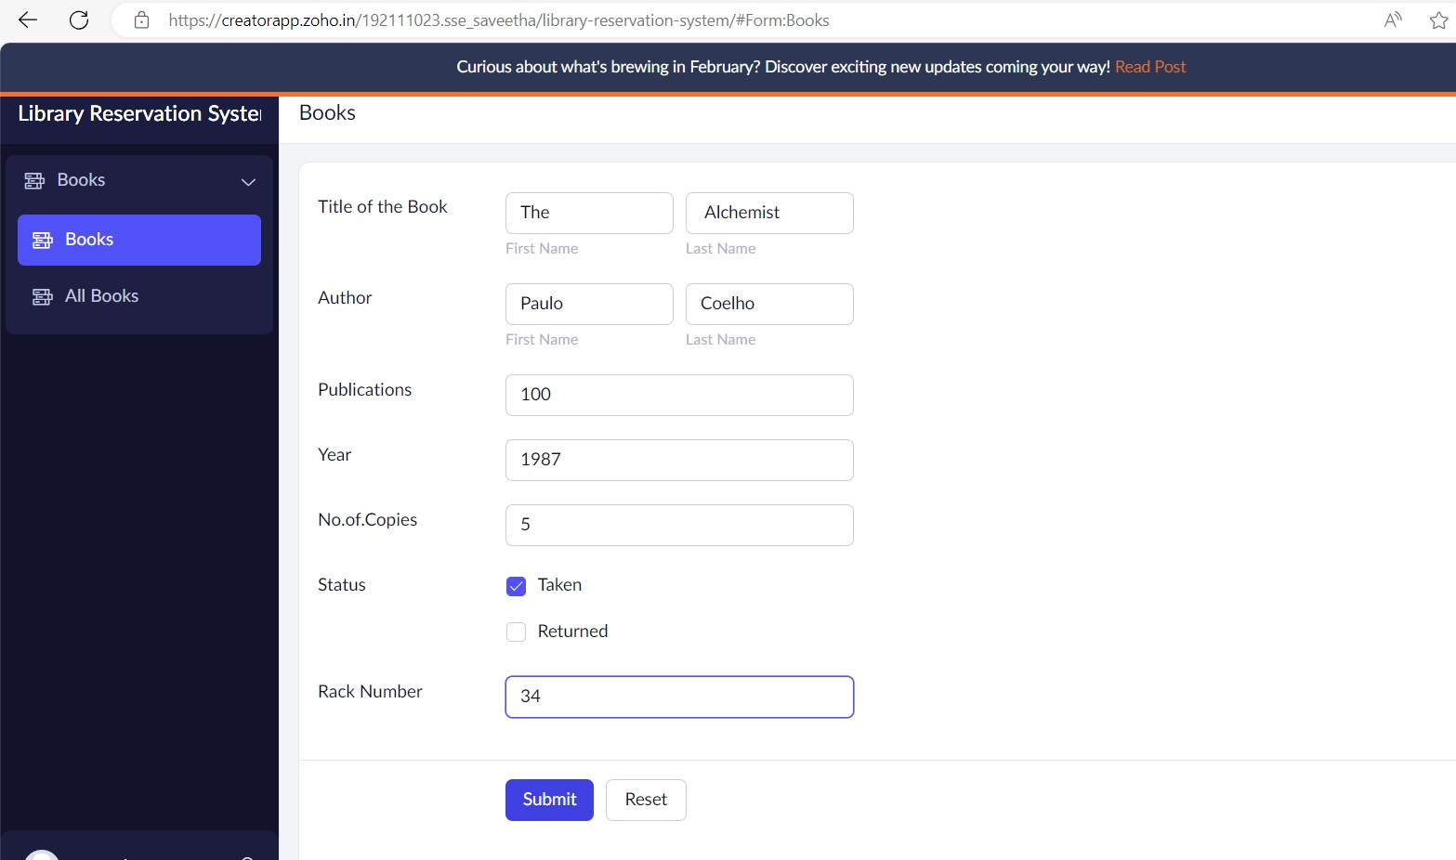

STEP 19: The report has been registered in the Book report.

